AIT 524: Weekly Assignment 12
Tanmoy Chowdhury
George Mason University

Author Note
This task is being submitted as an assignment task 12 for the course ‘Database Management Essential’ offered in Sprig 2018. For any kind of inquiry, feel free to contact at tchowdh6@masonlive.gmu.edu.

Online Drill
The ERD from assignment 04 & 06 has been used here.
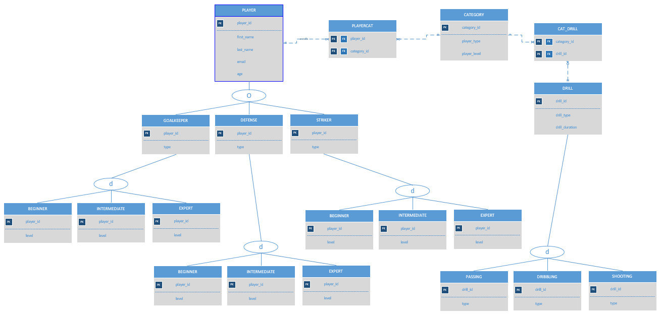
Figure 01: ERD from Assignment 04

Modification:
- I edited the entity name ‘BEGINNER’, ‘INTERMEDIATE’, ‘EXPERT’ as it seems like confusing for me when I am creating this subclass under their parent classes.
- I did not create ‘PASSING’, ‘DRIBBLING’ AND ‘SHOOTING’ entities as they inherit the same attribute from their parent class ‘DRILL’.
- I preferred to use all upper case in command and table name.

Procedure & Output:
- Write an SQL query that uses a single-row subquery in a WHERE clause. Explain what the query is intended to do.
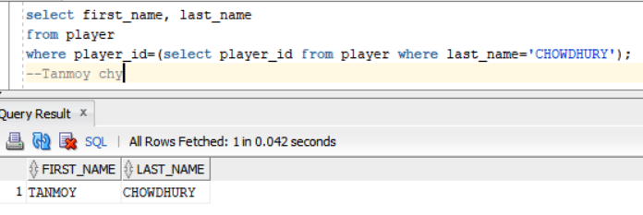
Explanation: This will find out the player’s name whose last name is chowdhury
- Write an SQL query that uses a multiple-column subquery in a FROM clause. Explain what the query is intended to do.
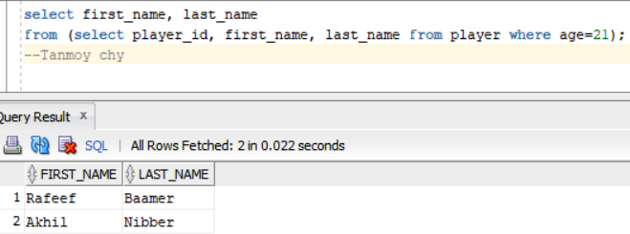
Explanation: This will find out the player’s first and last name with age 21.
- Write an SQL query that is based on multiple tables tables and uses a subquery with the GROUP BY statement and HAVING clause. Explain what the query is intended to do.
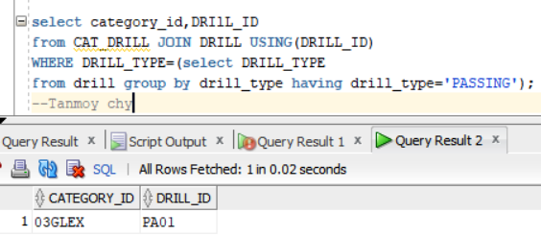
Explanation: It will find out the category id and drill id who belongs to the passing type drill.
- Write an SQL query that is based on multiple tables and uses a multiple-row subquery in a WHERE clause. The subquery will include the GROUP BY statement and another multiple-row subquery in a HAVING clause. Explain what the query is intended to do.
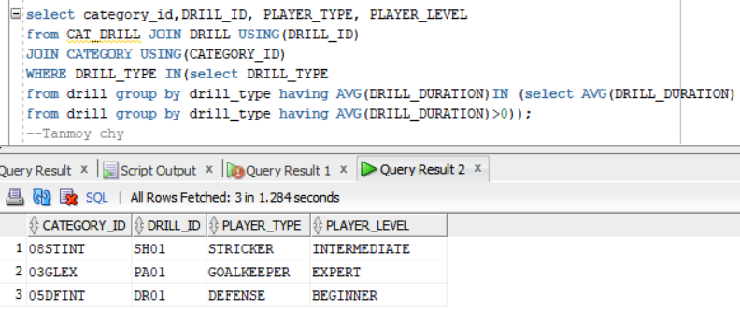
Explanation: It will find out the category id, drill id, player type and player level who performs those drill whose group average drill duration is greater than 0.
- Write an SQL query that joins three tables and uses any type of a subquery. Explain what the query is intended to do.
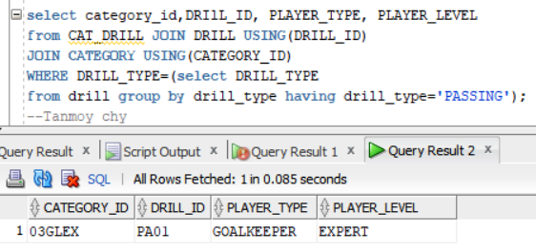

Explanation: This query will show category id, drill id, player type and player level of the passing type drill.

